**Dokumentasi rise-pms (no_stock)**

**Fitur:**

* Menentukan akan menggunakan supplier yang mana ketika ada transaksi masuk (TransactionEvent), dengan urutan penentuan yaitu blacklist, whitelist, dan kemudian menggunakan rule engine.
  + Blacklist -> melakukan blacklist pada customer yang tercatat pada database.
  + Whitelist -> melakukan whitelist yaitu jika suatu transaksi yang masuk terdiri dari client atau produk tertentu, maka penentuan supplier yang akan digunakan berdasarkan data yang ada pada database.
  + Rule engine -> Jika tidak di blacklist dan tidak ada whitelist, maka akan menggunakan Drools rule engine untuk menentukan supplier mana yang akan digunakan.
* Menentukan apakah akan beli atau tidak beli, serta menentukan supplier mana saja yang harganya memenuhi syarat (jika keputusannya adalah beli) ketika ada perubahan harga produk pada satu atau lebih supplier (PurchaseEvent). Hasil supplier mana saja yang harganya memenuhi syarat beli disort secara ascending.

**DB: rise_pms_2**

**ERD:**

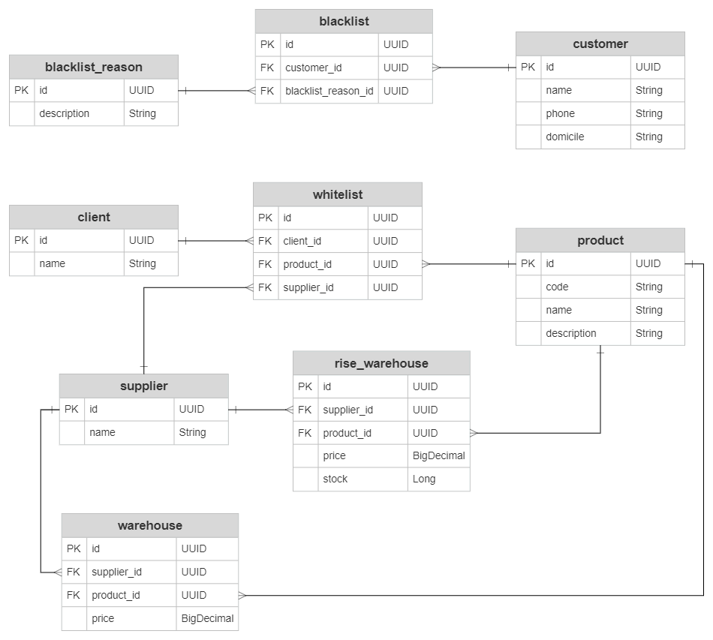

**Cara melakukan testing input (pada class id.riseteknologi.pms.endpoint.EventEndpoint):**

* <http://localhost:8082/event/transaction> (POST)

**Input:**

{

"clientId": "1254b4cf-92bc-4b54-a83b-908d0b4c28c0",

"customerId": "cf7278b3-5a99-464c-97c8-54988ac31976",

"productId": "73000bb4-873c-4d7d-bb8d-91b0d6535615"

}

**Output (Result):**

{

"productId": "73000bb4-873c-4d7d-bb8d-91b0d6535615",

"reject": false,

"buy": true,

"supplierId": "a5aba33a-d819-4f3a-9bbf-9ca5c799c5d9"

}

**Input:**

{

"clientId": "2916653e-e646-4109-9ed6-abfc5bcf2331",

"customerId": "c16f0889-6b3e-4d29-a46f-6c1971d15815",

"productId": "6d05477b-7880-4efa-9a11-3412e0e9c5f6"

}

**Output (Result):**

{

"productId": "6d05477b-7880-4efa-9a11-3412e0e9c5f6",

"reject": true,

"buy": false,

"supplierId": null

}

* <http://localhost:8082/event/purchase> (POST)

**Input:**

{

"productId": "73000bb4-873c-4d7d-bb8d-91b0d6535615",

"currentWarehouses": [

{

"supplierId": "09378fba-ec22-4d37-8eb6-b9a97153fa19",

"supplierName": "alto",

"productId": "73000bb4-873c-4d7d-bb8d-91b0d6535615",

"price": 1005

},

{

"supplierId": "a5aba33a-d819-4f3a-9bbf-9ca5c799c5d9",

"supplierName": "spi",

"productId": "73000bb4-873c-4d7d-bb8d-91b0d6535615",

"price": 980

},

{

"supplierId": "282c3650-09fa-4b53-b460-d497f2bc4fdb",

"supplierName": "albert",

"productId": "73000bb4-873c-4d7d-bb8d-91b0d6535615",

"price": 1000

}

]

}

**Output (Result):**

{

"productId": "73000bb4-873c-4d7d-bb8d-91b0d6535615",

"buy": true,

"eligibleSuppliers": [

{

"id": "a5aba33a-d819-4f3a-9bbf-9ca5c799c5d9",

"name": "spi",

"price": 980

},

{

"id": "282c3650-09fa-4b53-b460-d497f2bc4fdb",

"name": "albert",

"price": 1000

}

]

}

**Input:**

{

"productId": "73000bb4-873c-4d7d-bb8d-91b0d6535615",

"currentWarehouses": [

{

"supplierId": "09378fba-ec22-4d37-8eb6-b9a97153fa19",

"supplierName": "alto",

"productId": "73000bb4-873c-4d7d-bb8d-91b0d6535615",

"price": 1005

},

{

"supplierId": "a5aba33a-d819-4f3a-9bbf-9ca5c799c5d9",

"supplierName": "spi",

"productId": "73000bb4-873c-4d7d-bb8d-91b0d6535615",

"price": 995

},

{

"supplierId": "282c3650-09fa-4b53-b460-d497f2bc4fdb",

"supplierName": "albert",

"productId": "73000bb4-873c-4d7d-bb8d-91b0d6535615",

"price": 1050

}

]

}

**Output (Result):**

{

"productId": "73000bb4-873c-4d7d-bb8d-91b0d6535615",

"buy": false,

"eligibleSuppliers": null

}

